MODULE 7 | TEST CASES
Kao Yang • CSD-325
Screenshot 1: Initial City and Country Function
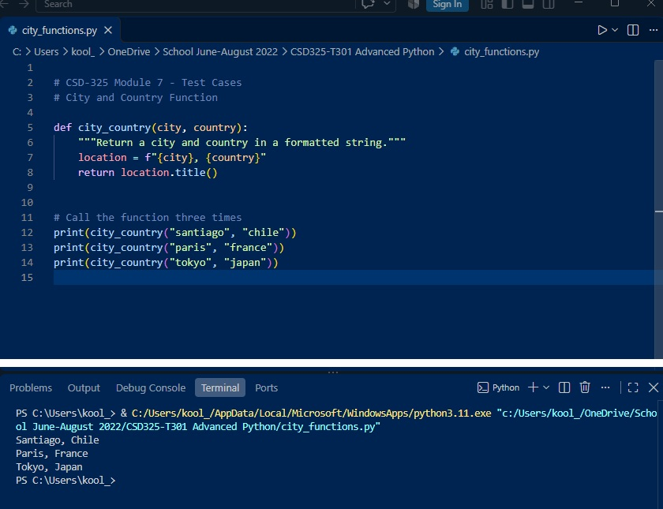
The Python program was created using a function called city_country() that accepts two parameters: a city and a country. The function combines the two values into a single formatted string and uses the title() method to capitalize the names. The function was tested using Santiago, Chile; Paris, France; and Tokyo, Japan. All three function calls produced the expected results.
Screenshot 2: Passing Unit Test
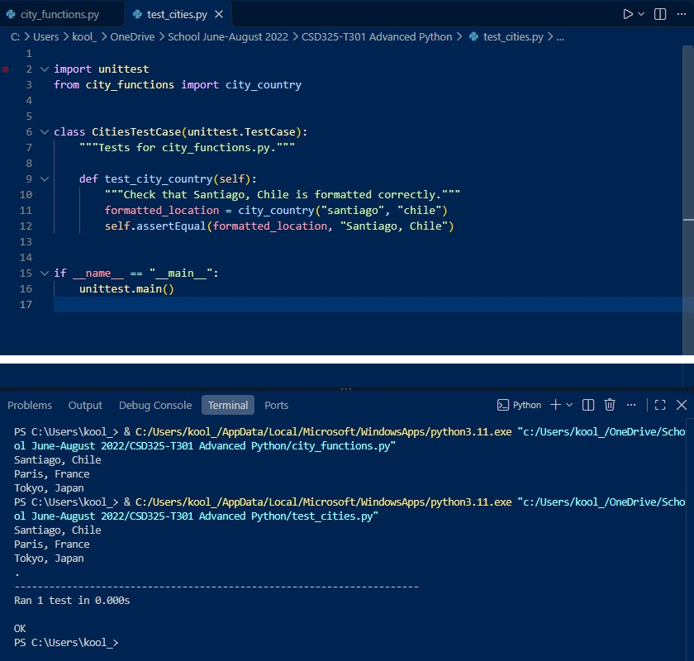
The test_cities.py program was created using Python's unittest module to verify that the city_country() function works correctly. The test used Santiago and Chile as inputs and compared the result with the expected output, "Santiago, Chile." The terminal displayed "Ran 1 test" followed by "OK," confirming that the function passed the unit test.
Screenshot 3: Failed Unit Test After Adding Population
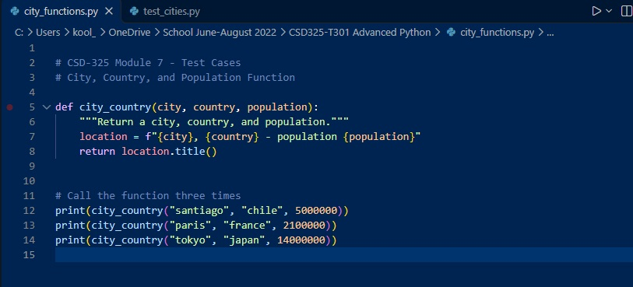
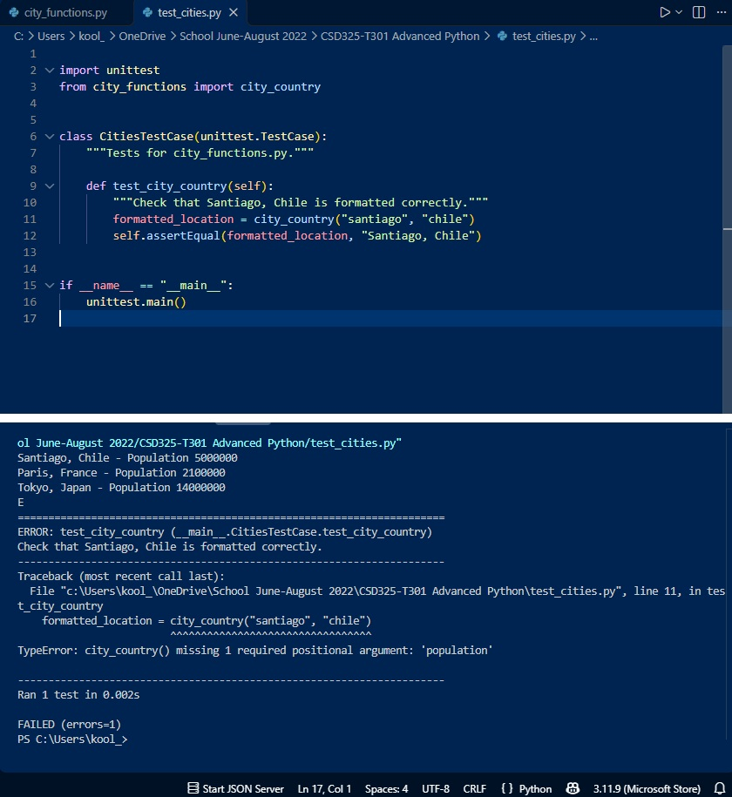
The city_country() function was modified to require a third parameter called population. When test_cities.py was executed again, the unit test failed because it only provided the city and country arguments. The terminal displayed a TypeError indicating that the required population argument was missing. This demonstrates how modifying a function can affect existing code and why unit testing is important.
Screenshot 4: Passing Unit Test With Optional Population
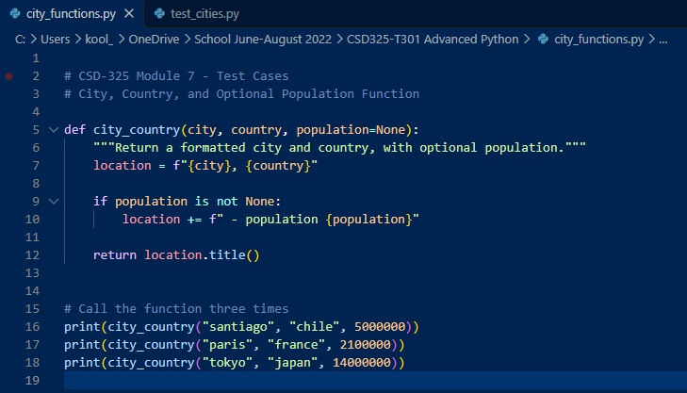
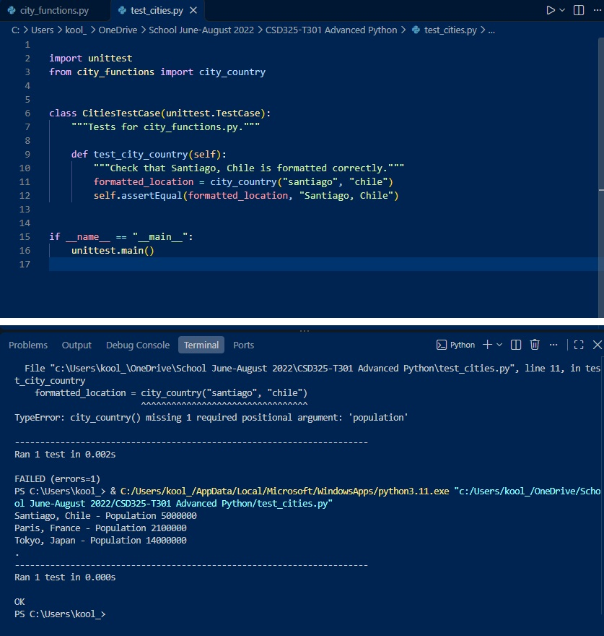
The city_country() function was updated to make the population parameter optional by assigning it a default value of None. This allowed the function to work with or without a population value. After running test_cities.py again, the test passed successfully, demonstrating that the original functionality was restored while still supporting population information.
Screenshot 5: Failed Unit Test After Adding Language
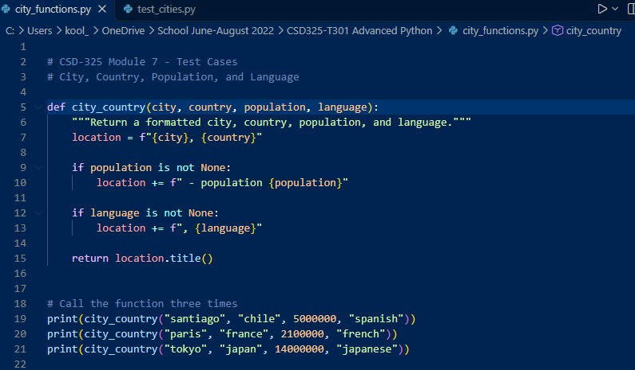
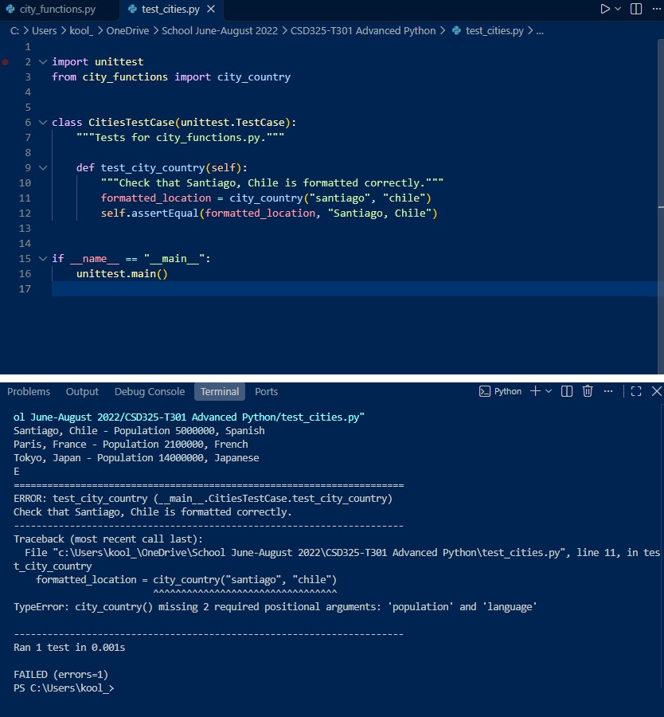
The city_country() function was modified to require four parameters: city, country, population, and language. When the original unit test was executed again, it failed because the test supplied only the city and country. The terminal displayed a TypeError indicating that the population and language arguments were missing. This demonstrated how adding required parameters can affect existing functionality.
Screenshot 6: Passing Unit Test With Optional Language
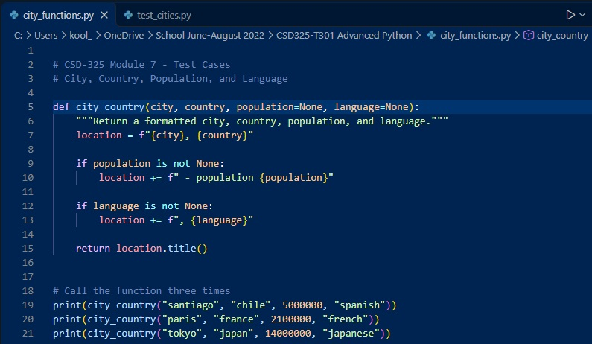
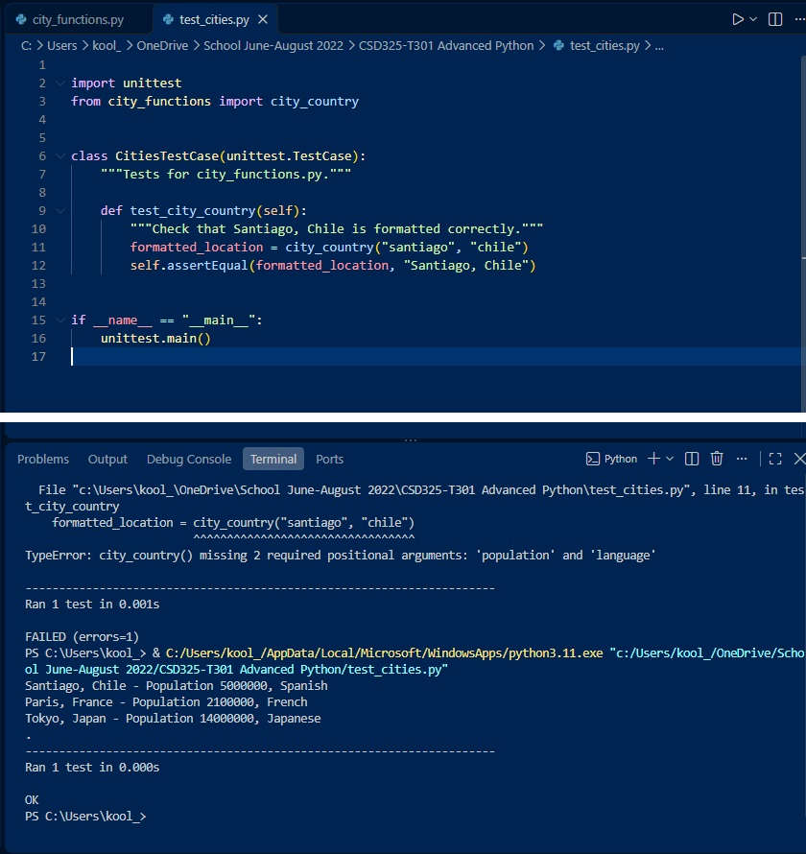
The city_country() function was modified to make both population and language optional parameters. After saving the changes, test_cities.py was executed again. The terminal displayed "Ran 1 test" followed by "OK," confirming that the function passed the unit test. This demonstrates that the function can accept additional information without affecting its original behavior.
Screenshot 7: Final Program Results
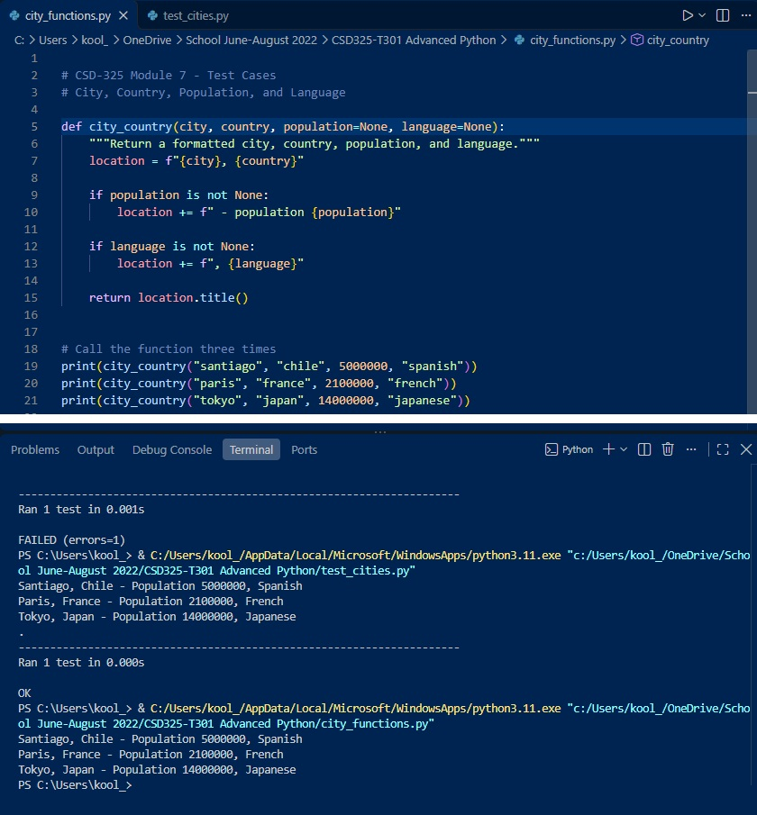
The final version of city_functions.py was executed using three different cities: Santiago, Paris, and Tokyo. Each function call included the city, country, population, and language. The program successfully displayed all three formatted results. The population and language parameters were also made optional, allowing the function to work with or without this additional information.

